Accident Obstruct, Identification & Notification System

ABSTRACT:

Accident threatens human lives more and mainly road accident is common today. During accident many people lose their life because medical services and family member not getting accidental information on time. In this paper, an efficient vehicle wireless system is designed and implemented for vehicle accident detection and reporting using accelerometer and GPS. Accelerometer sensor is used to detect crash and GPS give location of vehicle. In case of any accident, the system send automated message to the preprogrammed number such as family member or emergency medical services via GSM.

INTRODUCTION:

Road accidents constitute the major part of the accident deaths all over the world. According to the Insurance Institute for Highway Safety (IIHS), new cars and its high-tech safety features have helped to lessen auto related deaths over the past 12 years. Though it credits technology for lessening auto accidents, yet the IIHS cannot help accusing bad driving behaviours like drunken driving, speeding and not using seatbelts for still causing major traffic deaths. Automatic vehicle accident detection and messaging system is an embedded intelligence implanted into the automobile.

The purpose of the project is to find the vehicle where it is and locate the vehicle by means of sending a message using a system which is placed inside of vehicle system Most of the times we may not be able to find accident location because we don’t know where accident will happen. In order to give treatment for injured people, first we need to know where the accident happened through location tracking and sending a message to your related one or to the emergency services. Here we used assembly programming for better accuracy and GPS and GSM modules which helps to trace the vehicle anywhere on the globe. The exact location of the vehicle is sent to our remote devices (mobile phones) using GSM modem.

PROBLEM STATEMENT:

Whenever accident being met, the nearby people call the ambulance. The problem associated with this is that the victims depend on the mercy of nearby people. There is a chance that there are no people nearby the accident spot or people who are around neglects the accident. This is the flaw in the manual system.

PROJECT OBJECTIVES:

The following objectives are needed as a guide to achieve the goal of our project. They are

* To design a GPS and GSM based accident identification and information system using PIC.
* To trigger the car alarm when accidents are detected.
* To interface PIC microcontroller to GSM modem.
* To write a program in C programming language for the microcontroller to detect the sensors signals and trigger the alarm as well as send the alert message to owner via GSM modem.
* To provide security for the vehicle user and also detects the accident if occurred and informs the respective authority (like ambulance, police, owner etc.) through wireless technologies.
* To display the alarm status on 2x16LCD.

PROJECT SCOPE:

Few scopes and guidelines are listed to ensure the project is conducted within its intended boundary. This is to ensure the project is heading to the right direction to achieve its intended objectives.

The first scope is to design a controller that can control all the works in the system. The vibration sensor sense the vibration level and send data to microcontroller and can receive the GPS data, from satellite, display it at LCD and do transmit / receive to GSM module

Second scope of this project is to analysis the data from GPS receiver which can get the time, longitude, latitude, date and speed of the receiver. The data will be display at LCD Display.

The third scope is to store the data from GPS receiver into external memory EPROM. All the time, longitude, latitude, date and speed of the GPS receiver will be store into EPROM through the microcontroller. The last scope of this project is to trace the location of the accident using Global System for Mobile communications (GSM) (two way communication between user and GSM Module) and Global Positioning System (GPS).

APPLICATION:

* Can be used in Car/Motor Vehicles to secure the driver.
* Can be used by health department of government to survey the number of accidents if deployed in larger scale.
* With slight modification, can also be used in LIFTs in case damaged being done.
* With some modification we can also use this system for traffic estimation.

PROJECT LIMITATION:

The following limitations were note during our research;

* Difficult for communication in areas with poor coverage of GSM network and GPS communication
* Change of car ownership would result in need to reprogram the system details.
* Traffic jams can slow down the emergency responders.
* It does not work without network.

BUDGET: Total budget need 12k tk.

BACKGROUND STUDIES AND PREVIEW:

(Reference: 1)This study discusses about designing a Smart Display and Control (SDC) which will monitor the zone and maintains the specified speed in the zone levels, which runs on an embedded system. This system includes three modules; automatic speed control module, accident detection and information sending module and security enabling module. Automatic speed control module includes RF transmitter placed in specific location and RF receiver in the vehicle. Accident detection module includes GSM and GPS technology. Security enabling module includes sensory units which ensures the condition of seat belt and the driver. This module includes alcohol sensor and eye sensor. The smart display and control is composed of two separate units: Zone status Transmitter unit and Receiver (speed Display and Control) Unit.

(Reference: 5) When an accident occurs the information only be sent through GSM but there is no possibility to locate the spot. This project presents a GPS and GSM based accident identification and information system using GPS and GSM-SMS services. So the main intention of the project is to find the accident spot at any place and intimating it to ambulance through GPS and GSM networks. The GPS based vehicle identification module contains vibrating sensor GSM module and a GPS modem connected to the microcontroller. The receiver section consists of a GSM receiver and a PC. The transmitter section consists of a micro controller, GPS module, Key Pad, LCD, GSM transmitter and vibration sensor. An automatic alarm device for traffic accidents is introduced in this paper. It can automatically find a traffic accident, search for the spot and then send the basic information to first aid centre within small time seconds covering geographical coordinates, the time and circumstances in which a traffic accident takes place. GPS software is fitted in the vehicle will now start communicate with the satellite and get the latitude and longitude values and send the information to the centralized server. Then the server will search the nearest hospital and send the accident information to the hospital. The hospital will then be sending the ambulance to the accident zone. Then the injured people will be saved as soon as possible. This process will save time in particular for the areas in the outer part of main zone.

(Reference: 7) The aim of our work is to find the vehicle accident location by means of sending a message using a system which is placed inside of vehicle system. The main purpose is to provide security to the vehicle in very reasonable cost. So in this work we are using the basic microcontroller AT89C52 for cost effective and also for easy understanding. Here we used assembly programming for better accuracy and GPS and GSM modules which helps to trace the vehicle anywhere on the globe. The exact location of the vehicle is sent to our remote devices (mobile phones) using GSM modem.

(Reference: 8) Vehicle accidents are one of the most leading causes of fatality. The time between an accident occurrence and the emergency medical personnel are dispatched to the location of accident is the critical factor in the survival rate after an accident. By minimizing the gap time, mortality rate can be reduced. One approach to reduce the delay time is to use the Real Time Wireless Accident Tracker Using Mobile Phone, a system which automatically senses the occurrence of an accident of a vehicle and immediately notify central emergency dispatch server of the location of accident using Global Positioning System (GPS). The main purpose of this research is as an early accident detection. This system uses PIC 16F microcontroller, piezoelectric sensors, GPS and Global System for Mobile (GSM) modules to detect traffic accidents. When an accident occurs, the piezoelectric sensor detects and measures the severity of the force impacted on the vehicle and sends out a help message to central emergency server. Upon acknowledgement from the server, the system sends out another message containing GPS coordinate of the location.

(Reference: 9) With the growing population the use of vehicles has become superfluous and this has led to the accidents increasing at an alarming rate resulting in a large loss of property and human life. This project aims at finding the occurrence of any accident and reporting the location of accident to the previously coded numbers so that immediate help can be provided by ambulance or the relatives concerned. GSM technology is used to intimate the vehicle position in the form of latitude and longitude coordinates through sms. The location spot is retrieved using Global Positioning System which is a navigational system using a network of satellites orbiting the earth. Sensors such as vibration, alcohol and fire detectors detect signal in case of an accident occurrence and send a signal to the connected microcontroller .The controller in turn operates the relay to blow the airbag and automatically lock the brakes. Meanwhile a message reaches to the necessary help and thus ambulance service and required aid can reach in the shortest time possible. This system can also aid companies in the rental vehicle business to keep a track of the vehicular activity by sending message at regular intervals to the authorized numbers

COMPARISON BETWEEN EXISTING SYSTEM AND PROPOSED SYSTEM:

PROPOSED METHOD:

In the proposed system, we have avoided the false alarm situation caused for some conditions, increased the accuracy of accident detection using more than one sensor, cut the project cost by using the already existing infrastructure available in the victim’s mobile phone. To avoid the false alarm we have one manual switch in the vehicle itself which must be pressed within 10 second of false accident detection and hence avoiding any false intimation. We are using front bumper sensor, position encoder along with the accelerometer sensor in order to increase the accuracy of accident detection. Bumper sensor will tell the microcontroller how much force/pressure has been applied on it and its obvious the pressure will be more in case of accident. Position encoder is used for calculating the speed of vehicle and it is expected to change drastically when accident being met and adding another layer of reliability. The accelerometer sensor as usual tells the microcontroller if there is sudden change in the acceleration. Now a day’s every android phone have inbuilt GPS, GSM modules which we are using in order to get the accident spot location and to send the SMS.

DIAGRAM:

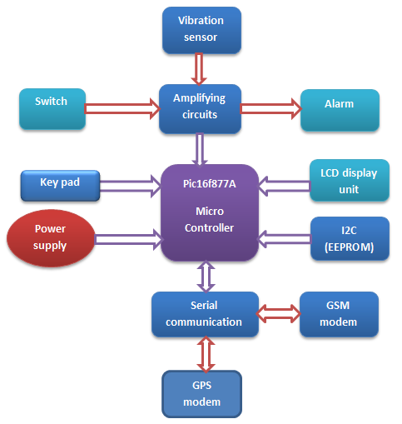

GSM MODEM:

GSM is global system for mobile communication and used to send message to pre-programmed number. A GSM modem is a specialized type of modem which accepts a SIM card and operates over a subscription to a mobile operator just like a mobile phone. From the mobile operator perspective a GSM modem looks just like a mobile phone. A wireless modem behaves like a dial modem. The main difference between them is that a dial-up modem sends and receives data through a fixed telephone line while a wireless modem sends and receives data through radio waves. Advantages of using this modem will be that you can use its RS232 port to communicate and develop embedded applications. Application like SMS control, data transfer, remote control and logging can be developed easily. The SIM 900 is complete Quad- band GSM/GPRS solution in a SMT module which can be embedded inthe customer applications. Featuring an industrystandard interface, the SIM 900 delivers GSM/GPRS 850/900/1800/1900 MHz performance for voice, SMS, data and Fax in a small form factor and with low power consumption. With a tiny configuration of 24mm\*24mm\*3mm, SIM 900 can fit almost all the space requirement in your M2M application, especially for slim and compact demand of design. SIM900 features GPRS multi slot class 10/ class8 (optional) and supports the GPRS coding schemes CS-1, CS-2, CS-3 and CS-4. GSM modems support an extended set of AT commands.

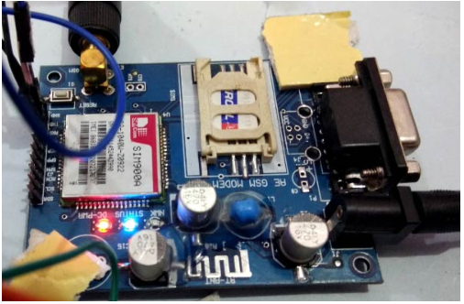

GPS DEVICE:

The Global Positioning System (GPS) is a space based global navigation satellite system (GNSS) that provides reliable location and time formation in all weather and times anywhere on the globe. When people talk about a GPS, they usually mean a GPS receiver. GPS used a constellation of 27 earth orbiting satellites (24 in operation and three extras in case one fails). These satellites, which are equipped with atomic clocks, transmit radio signal that contain their exact location, time and other information. The GPS satellites act as a reference point from which receivers on the ground detect their position.

The fundamental navigation principle is based on the measurement of pseudo ranges between the user and four satellites. Ground station precisely monitor the orbit of every satellite and by measuring the travel time of the signal transmitted from the satellite four distances between receiver and satellites will yield accurate position, direction and speed. Though three-range measurements are sufficient, the fourth observation is essential for solving clock synchronization error between receiver and satellite. Whichever the modem is used it works based upon the NMEA 0183protocol. Basically, a GPS receiver determines four variables: longitude, latitude, height and time. The data can be taken in to the controller by using UART protocol.

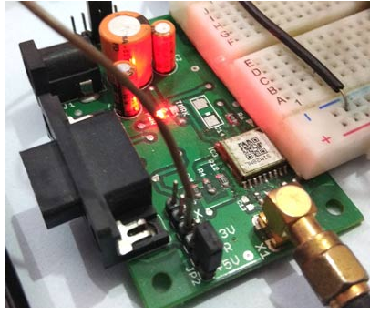

SYSTEM ANALYSIS AND DESIGN:

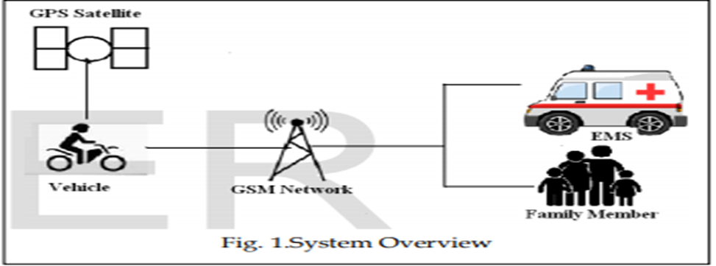

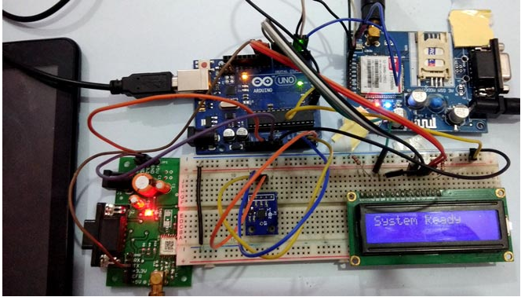

The main objective of this work is to reduce the human death rate in road accident. The paper proposed a system to give quick assistance to the people who got the accident. The fall detection and reporting system for the vehicle can gain the attention because the system will save the life and give medical treatment on time. The system consists of ARM7 micro-controller unit, MEMS accelerometer, GPS device, GSM module, Temperature sensor, gas sensor and Alcohol sensor. An Accelerometer is used to detect the acceleration. It is the main sensor used to detect the accident. Once the accident is detected GPS collect the current position values which include latitude (N or S), longitude (E or W), date and time. The location values are given to microcontroller. Controller gives this information to GSM module. By using GSM module we can send the message to family members or EMS.

Here the serial communication interface UART is used for the communication between the microcontroller, GSM and GPS module. The RS232 communication standard is used for the electrical signal characteristics such as voltage levels. This communication enables point to point data transfer. A high performance 16/32 bit microcontroller unit is used to process and store real time signal from the accelerometer and various sensor. Through Temperature sensor we can measure temperature in vehicle and which is display on LCD continuously. Motor stop automatically when alcohol is detected through alcohol sensor. Gas sensor is used for gas leakage detection and red LED blink when gas is detected. All the data of these sensor and GPS data are stored in memory card for analysis of accident cause. The total system is placed inside a vehicle which is not visible to others. We can implement robust package design so that system is safe from water and dust.

SYSTEM IMPLEMENTATION AND TESTING:

The mobile number of the user should be included in the software programming in order to receive the accident location values from the SIM card which we are using in GSM modem. Motor stops automatically when alcohol is detected. Red LED on when gas is detected through gas sensor. Here one switch is provided to send a message we are safe, when there is no serious injury happen. Due to this we can save the valuable time of emergency medical services.

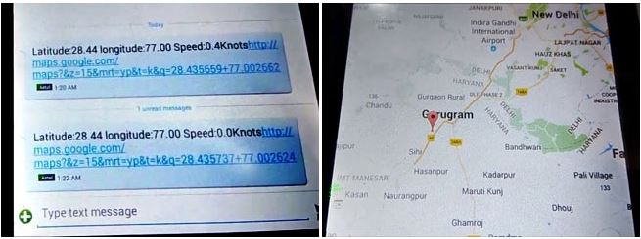

HARDWARE REQUIREMENTS:

* GSM module
* GPS module
* Vibration sensor
* Pic16f877A microcontroller
* Liquid crystal display (LCD)
* Key pad
* I2C (EEPROM)
* Arduino Uno
* Connecting Wires
* Breadboard or PCB
* Power supply 12v 1amp

SOFTWARE REQUIREMENTS:

* Proteus simulation software
* Arduino compiler
* Programming Language: C
* GOOGLE MAP
* serial communication

ADVANTAGE:

* Low power hardware components being used in our system.
* Uses some already existing hardware components of mobile phone hence lower the total cost/budget involved.
* Use of more than one sensor increases the accuracy of our system.
* False alarm switch can avoid any false intimation hence add more towards the reliability.

DISADVANTAGE:

* Bluetooth of phone monitors the accident regularly hence takes the power even if no accident being met.
* If the phone battery is dead by any means then we can’t intimate to the concerned people.

CONCLUSION:

This study solves the issues like automatic speed control mechanism, accident detection and information sending. From this we conclude that this system will reduce the accidents and save the human lives.

On the whole this system proves to be very cost effective and efficient. The experimentations and results prove that the system is easily implementable in real time. This system can also be extended by inducing automation concepts like automatic driverless vehicle system, inter vehicular communication etc.

REFERENCES:

(1) <http://maxwellsci.com/print/rjaset/v4-3323-3326.pdf>

(2) <http://pnrsolution.org/Datacenter/Vol3/Issue3/135.pdf>

(3)<https://www.ijser.org/researchpaper/Wireless-System-for-Vehicle-Accident-Detection-and-Reporting-using-Accelerometer-and-GPS.pdf>

(4)<https://circuitdigest.com/microcontroller-projects/arduino-based-accident-alert-system-using-gps-gsm-accelerometer>

(5)<https://www.academia.edu/23644471/A_PROJECT_REPORT_ON_GSM_AND_GPS_BASED_ACCIDENT_IDENTIFICATION_AND_INFORMATION_SYSTEM_JIMMA_INSTITUTE_OF_TECHNOLOGY_DEPARTEMENT_OF_ELECRICAL_AND_COMPUTER_ENGINEERING>

(6)<https://www.slideshare.net/SolomonMutwiri/accident-detection-and-notification-system-77037088>

(7) <https://www.ijser.org/researchpaper/Automatic-Vehicle-Accident-Detection-And-Messaging-System-Using-GPS-and-GSM-Modems.pdf>

(8) <https://ieeexplore.ieee.org/document/8123430>

(9)<http://www.jetir.org/papers/JETIR1505018.pd>